**Lab7: Outputs and Self-scored Rubric**

**Name: Ethan Souders**

1. **Self-scored Rubric**

Please record the points you think you should earn

|  |  |  |
| --- | --- | --- |
| **Requirements** | Points Assigned | **Points Earned** |
| Insertion | 10 | **10** |
| Hight, size, leaf count | 15 | **15** |
| pre-order traversal | 5 | **5** |
| in-order traversal | 5 | **5** |
| post-order traversal | 5 | **5** |
| Delete 90 | 10 | **10** |
| Delete 40 | 10 | **10** |
| Delete 20 | 20 | **15** |
| operator=() | 10 | **10** |
| Clear() and print() | 10 | **10** |
| Total | 100 | **95** |

1. **Menu**

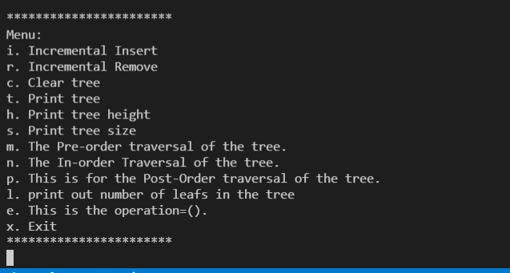

1. **Insert keys (continued from the left column to the right column**

|  |  |  |
| --- | --- | --- |
|  |  | Press q to exit insertion mode |

**2. Height, size, leaf count**

|  |
| --- |
|  |

1. **Pre-order, In-order, Post-order traversals**

|  |  |
| --- | --- |
| **Pre-order** |  |
| **In-order** |  |
| **Post-order** |  |

**5. Delete 90, 40, 20 using the immediate successor**

|  |  |
| --- | --- |
| **Delete 90**  **(leaf)** |  |
| **Delete 40**  **(internal node with two children)** |  |
| **Delete 20**  **(internal node with two children that includes deletion of an internal node with a single child)** |  |

**6. operator=() & clear()**

|  |  |
| --- | --- |
| **operator=()** | **clear() and print the tree** |
|  |  |